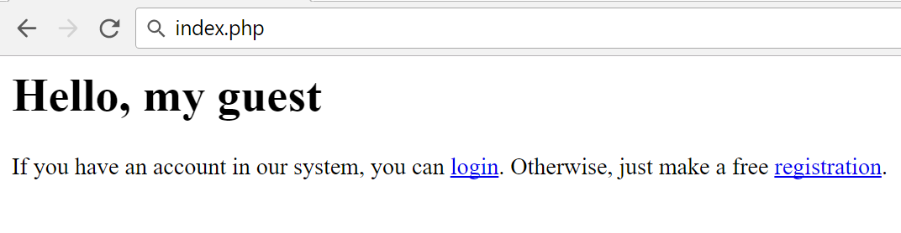
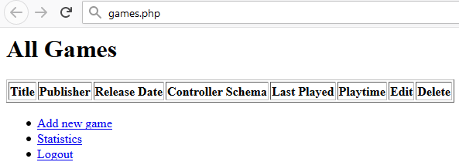
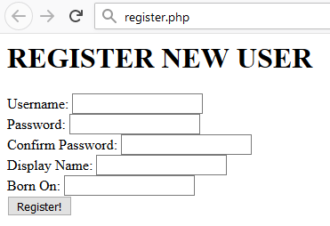
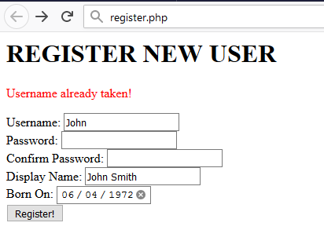
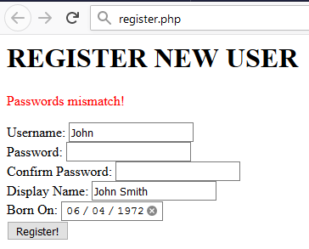
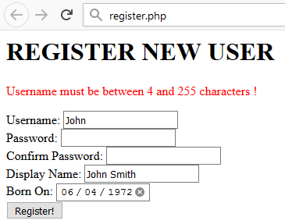
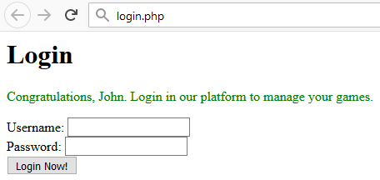
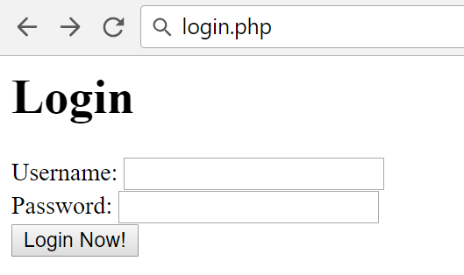
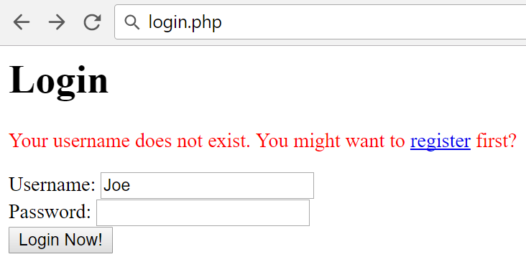
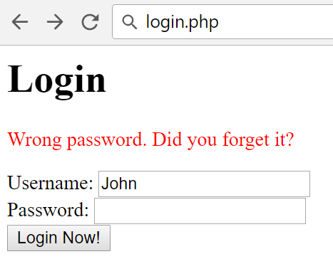
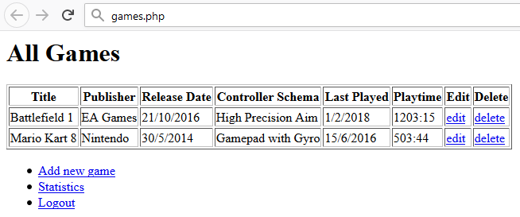
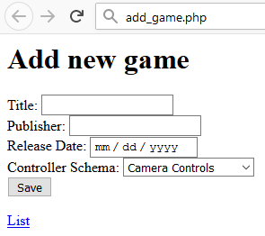
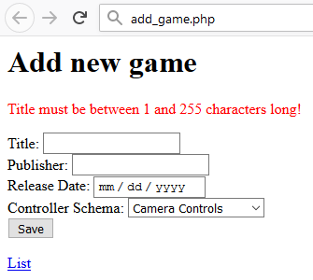
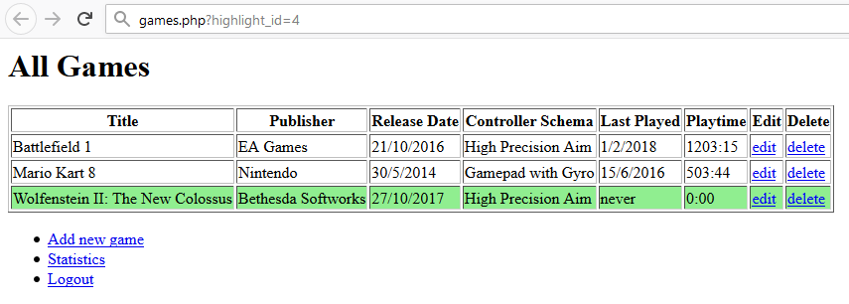
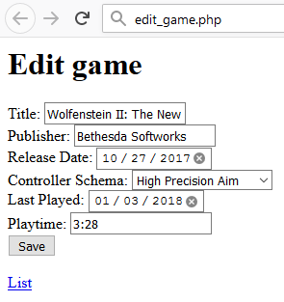
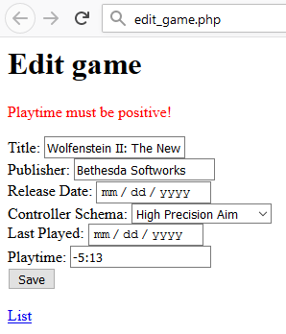
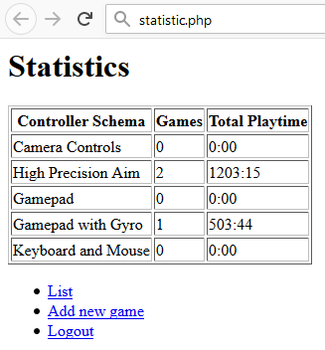

Exam Retake – Game Catalog
You need to create a web application where users see and manage games and controller settings for them. Usually the users will visit the home-page, navigate either to Registration or Login.
After login they go to Catalog page, where all games are listed. Then they can either add a game, edit or delete existing, or see the Statistics of all controller schemas.

Expected Result
General rules:
- No blank lines should be left
- Going on new line (click ENTER) in the same text should be done, only after the sentence ends (after full stop)
- Each title is Heading 1
- All attribute values and tags are lowercase
- All name fields are lower_snake_case variant of the text/value
- All tables have head and if they are filled with data, they have a body
- Only direct child tags go on new line e.g. <tr> is on new line after <thead>, but <a> in <li> is not on new line.
- All success messages are stored in the session under the “success” key and are immediately deleted from session after visualization. They are visualized on the next line after the title in a paragraph with style color:green.
- All error messages are visualized on the next line after the title in a paragraph with style color=red.
- All relational dropdowns follow the convention: name_snake_case_id
index.php:
- When user is not logged ( https://judge.softuni.bg/Contests/Compete/Index/899#0 (1 point)):
- When user is logged ( https://judge.softuni.bg/Contests/Compete/Index/899#1 (1 point)):
register.php:
- Before form is submitted ( https://judge.softuni.bg/Contests/Compete/Index/899#2 (1 point)):
- Form is submitted, but there are username duplicates ( https://judge.softuni.bg/Contests/Compete/Index/899#3 (1 point)):
- Form is submitted, but the password and the confirm password field differs:
- Form is submitted, but validation did not pass:
Show the error only for the first field the validation did not pass (they might all be out of range). The message is in the format:
  - For text fields: “{Field Name} must be between {MIN_LENGTH} and {MAX_LENGTH} characters!”.
  - For number fields: “{Field Name} must be between {MIN_VALUE} and {MAX_VALUE}!”
- After successful submission ( https://judge.softuni.bg/Contests/Compete/Index/899#4 (1 point)):
login.php:
- Before form is submitted ( https://judge.softuni.bg/Contests/Compete/Index/899#5 (1 point)):

- Form is submitted, but username does not exist:
- Form is submitted, but the password is not the same:
- After successful login:
If there are games, list them sorted by last_played, with games that have been played more recently appearing first in the list. If there are two or more equal dates (including null values), order them by primary key of the game ( https://judge.softuni.bg/Contests/Compete/Index/899#6 (1 point)).
add_game.php (Add new game):
- Before form is submitted ( https://judge.softuni.bg/Contests/Compete/Index/899#8 (1 point)):
- Form is submitted, but validation did not pass:
- After successful submission, the game is added, redirected to the list of games, and the row with new game is highlighted with style background-color:lightgreen ( https://judge.softuni.bg/Contests/Compete/Index/899#7 (1 point)):

edit_game.php?id={game_id} (Edit existing operation):
- Before form is submitted:
- Form is submitted, but validation did not pass:
- After successful submission, the game is edited, redirected to the list of games, and the row with editted game is highlighted with style background-color:lightgreen

delete_game.php?id={game_id} (Delete existing operation):
- Deletes the operation and redirects to operations list again.

statistics.php (Report for controller schemas):
Lists all controller schemas, the game count that uses each schema and total playtime for all games, ordered by the schema name:

Database
Create a database "games" and add the following tables:

Data Definition
Submit in judge the create table statements as follows:

DDL – Users (15 points)
users
Column Name |  | Type
username |  | String
password |  | String
display_name |  | String
born_on |  | date

DDL – Games (25 points)
games
Column Name | Type
title | String
publisher | String
release_date | Date
controller_id | int
last_played | Date
playtime | int
user_id | int

DDL – Controller Schemas (10 points)
controllers
Column Name |  | Type
name |  | String

DDL – Relations (50 points)
Add the needed relations to the above tables and paste in judge all CREATE TABLE definitions at once, this time with relations.
Save the DDL in export.sql file in the top-level directory of your project.

Data Manipulation
Submit in judge queries for adding or taking data as follows:

DML – Add Controller Schemas (5 points)
Submit a query (or queries) which adds the following controllers:
name
Camera Controls
High Precision Aim
Gamepad
Gamepad with Gyro
Keyboard and Mouse

DML – Add Users (10 points)
Submit a query (or queries) which adds the following users:
username | password | display_name | born_on
george | $2y$10$fnncUQdY0MQJuqIgFk1BGOQKkxpSmPXTh0IX.av4TB5Tp9CzM2PS. | xXx_noScope | 2/1/2006
vince | $2y$10$Q7A5iTVJBYnaY5X5gMwqOuoD5pGcDooG9c7k5PqM2.0L9LRSmDX7K | VVVVV | 3/23/1994
maria | $2y$10$qh.HcdLKZwsnl4GglZ43h.Cti5Q9WGPYjnTbJu9Ad28e3jZWRFv5G | mar4eto13 | 5/15/2003
alice | $2y$10$S.idSMp0yZKUZEGqmSCRMeG33IZJrtWCYvzbQc.rYVKe8fmBdq3mm | Punisher | 6/8/1998

DML – Add Games (20 points)
Submit a query (or queries) which adds the following operation and consider the needed relational data:
title | publisher | release_date | controller | user
Call of Duty: WWII | Activision | 11/3/2017 | Gamepad | george
Battlefield 1 | EA Games | 10/21/2016 | High Precision Aim | maria
Wolfenstein II: The New Colossus | Bethesda Softworks | 10/27/2017 | High Precision Aim | maria
Mario Kart 8 | Nintendo | 5/30/2014 | Gamepad with Gyro | maria
PlayerUnknown's Battlegrounds | Bluehole, Inc. | 12/20/2017 | Keyboard and Mouse | vince

DML – Get All Users (10 points)
Get all users data, without the password and the primary key, ordered by their age, then by primary key:
username | display_name | year of born_on
vince | VVVVV | 1994
alice | Punisher | 1998
maria | mar4eto13 | 2003
george | xXx_noScope | 2006

DML – Get First Three Games (15 points)
Get the first three games from the table of games, ordered by release_date (from past to present), then by the primary key ascending:
id | title | publisher | release_date | controller_id | user_id
4 | Mario Kart 8 | Nintendo | 5/30/2014 | 4 | 3
2 | Battlefield 1 | EA Games | 10/21/2016 | 2 | 3
3 | Wolfenstein II: The New Colossus | Bethesda Softworks | 10/27/2017 | 2 | 3

DML – Get All Games (20 points)
Get all operation’s primary key, title, publisher, controller schema, user name ordered by primary key ascending:
id | title | publisher | controller | user name
1 | Call of Duty: WWII | Activision | Gamepad | george
2 | Battlefield 1 | EA Games | High Precision Aim | maria
3 | Wolfenstein II: The New Colossus | Bethesda Softworks | High Precision Aim | maria
4 | Mario Kart 8 | Nintendo | Gamepad with Gyro | maria
5 | PlayerUnknown's Battlegrounds | Bluehole, Inc. | Keyboard and Mouse | vince

HTML

Register Form (20 points)
Submit a zip archive with an HTML file which is a form, registering users. Follow the constraints below:
- Username with minimum length of 4 symbols
- Password with minimum length of 6 symbols
- Confirm password with minimum length of 6 symbols
- Display name with minimum length of 5 symbols
- Born On with valid date (between 1900 and current year)
- Button, submitting the form with value “Register now”
All fields are required. Use a convention for name attributes: lower_snake_case.

Successful Register Page (30 points)
Submit zip archive with “index.php” and “login.php” which accepts success message in the session and prints it above the login form as shown:

Login Page (20 points)
Submit a zip archive with an HTML file with form with:
- Heading 1 text: “Login”
- Username
- Password
- Button, submitting the form with text “Login now”
All fields are required. Use a convention for name attributes: lower_snake_case.

Add Game Page (40 points)
Submit a zip archive with one html file, contains an HTML form with:
- Title with minimum length of 1 symbol
- Publisher with minimum length of 1 symbol
- Release date containing valid date
- Controller Schema which is empty dropdown (will be later populated with PHP)
- Button, submitting the form with text "Save"
- Hyperlink to index page
All fields are required. Use a convention for name attributes: lower_snake_case.

Structure
After each subtask below, submit a zip archive with the project in judge. You are required to have index.php in the project, even if it is initially empty. Consider all object oriented best practices you have been taught during the course.

Initial File Structure (30 points)
- Create a file named “export.sql” holding all the CREATE TABLE statements (without CREATE DATABASE). Put it in the top-level directory;
- Create a directory named “Config” in the top-level directory. Put file named “db.ini” holding the database connection information under the following keys: dsn, user, pass;
- Create endpoints (front layer) for all possible pages in the top-level directory: index, register, login, add game, edit game, statistics and logout;
- Extract common operation such as autoloading classes in "common.php".

Database Abstraction Layer (50 points)
Create an abstraction layer over the database operations in three stages – prepare -> execute -> take result. All objects should be in the \Database namespace.

Repository Layer (60 points)
Following the naming convention “{EntityName}Repository”, create repository layer in the namespace \GameCatalog\Repository

Service Layer (60 points)
Following the naming convention “{BusinessEntity}Service”, create service layer in the namespace \GameCatalog\Service

GameCatalog Management Application (200 points)
Make all the layers to work, according to the structure and business requirements. and submit the zip archive in judge.

